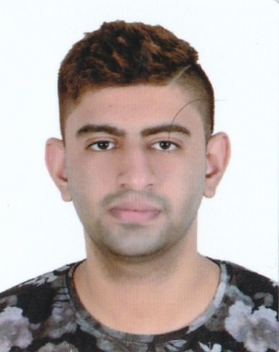Yahya ali alstrawi

* **E-mail: y4hy4alstrawi@gmail.com**
* **Phone: 33199681**
* **Sex: male**
* **Date of birth: 1997/1/27**
* **Nationality:** **Bahraini**
* **CPR: 970108303**
* **Age: 22**

Objective of job:

Get a job that fits with schedule of my study

Work experience:

|  |  |  |
| --- | --- | --- |
| **Work experience** | **START** | **END** |
| 1-KFC restaurant (cashier & kitchen) | 2017-3-15 | 2017-11-20 |
| 2-Texas restaurant (kitchen) | 2018-5-10 | 2018-6-1 |
| 3-hungerstation (driver) | 2018-7-1 | 2019-3-29 |

Qualifications:

General Secondary School (Technical)

Education:

* Electronics (87%) 2011 — 2014
* I still study at the university of Bahrain

Master: Bachelor of Process Instrumentation and Control Engineering (second year)

Interests:

* Reading
* Learn English and other languages
* Developing the educational level

Languages:

* Arabic (native)
* English (intermediate)

Hobbies:

* Swimming
* Football